**Assignment 15.1**

1. Write a simple program to show inheritance in Scala.

-- Create a class person

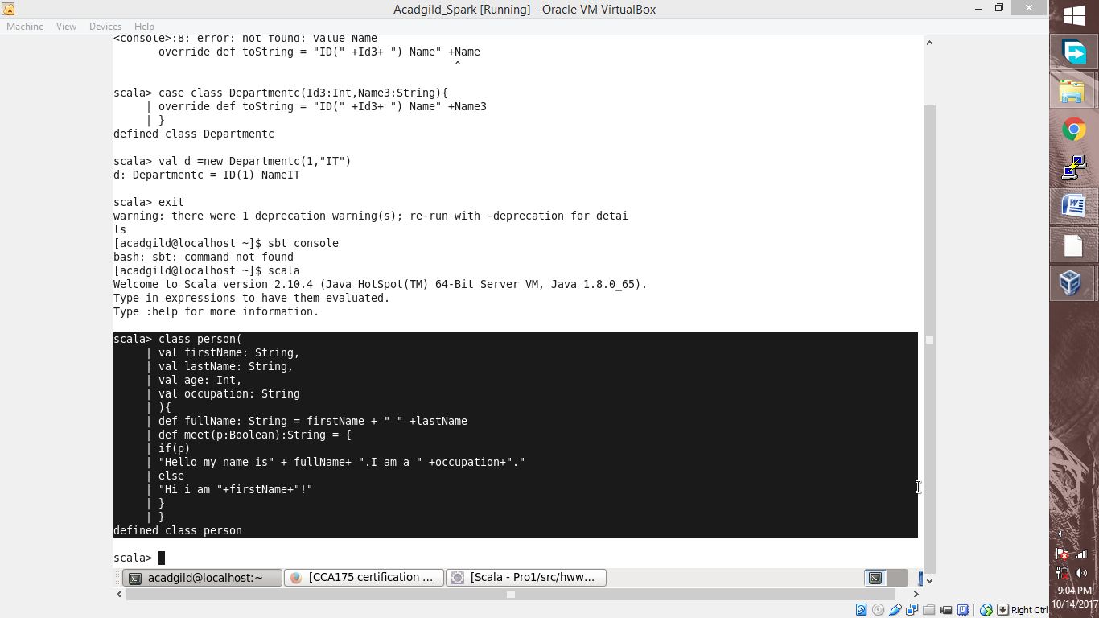

Extend a person class in Operson class

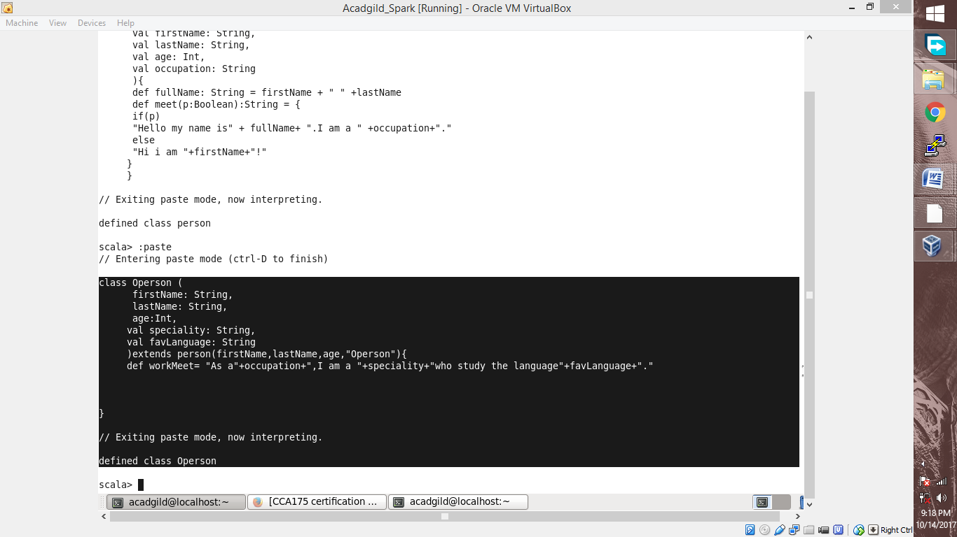

passing values to variables defined in above two class and printing data / text of a function defined in class ‘Operson’

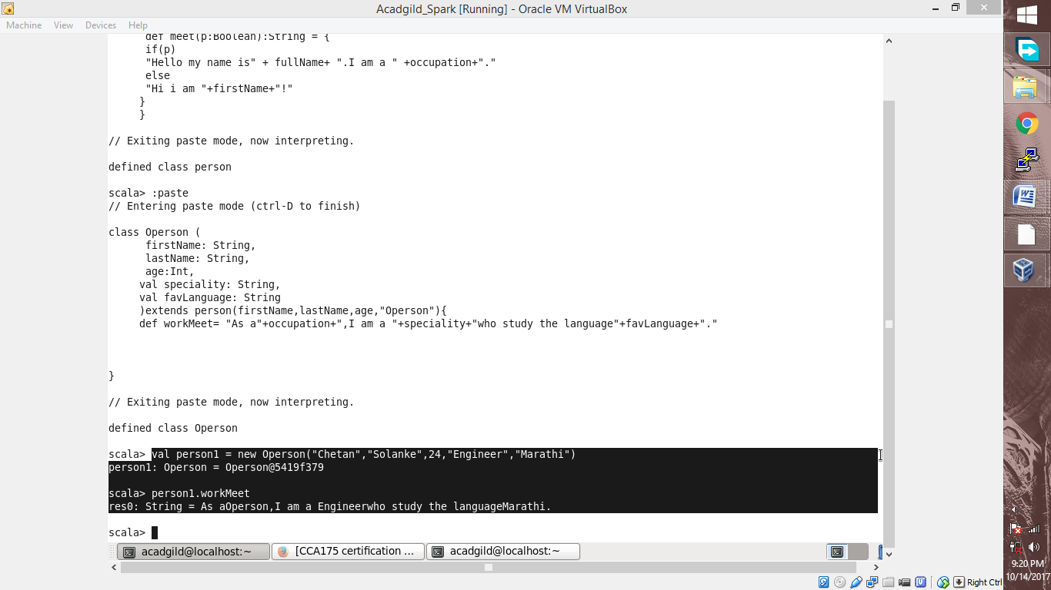

Printing different output of Operson and person class

